[5:-11] (array([-16.97419912, 21.95103989]), array([[ 0.01528003, -0.03590606],

[-0.03590606, 0.08447943]])) 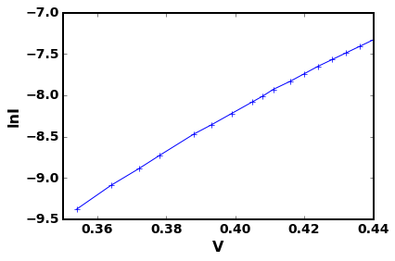

[6:-11] (array([-16.94735184, 21.88835268]), array([[ 0.01477047, -0.03470015],

[-0.03470015, 0.08161955]])) 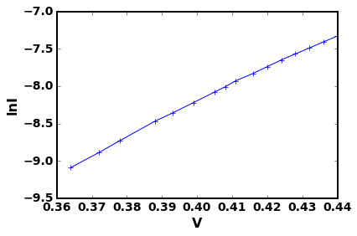

[7:-11] (array([-16.88364756, 21.73977978]), array([[ 0.01323489, -0.03106971],

[-0.03106971, 0.07301999]])) 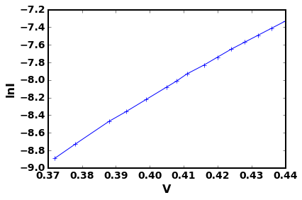

[8:-11] (array([-16.82669245, 21.60712039]), array([[ 0.01160803, -0.02723612],

[-0.02723612, 0.06397169]])) 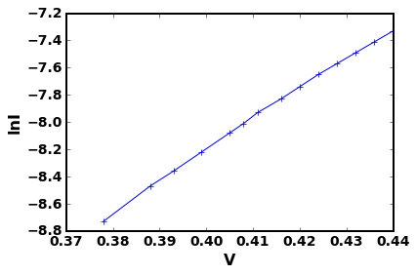

[9:-11] (array([-16.76288074, 21.45863338]), array([[ 0.00997041, -0.02337516],

[-0.02337516, 0.0548546 ]]))

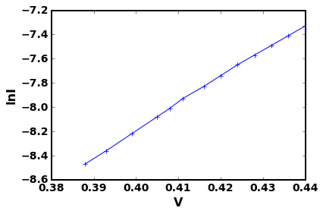

[10:-11] (array([-16.71007494, 21.33603256]), array([[ 0.01038989, -0.02433322],

[-0.02433322, 0.05703687]])) 